Disaster Prediction Search and Rescue Operation Using Machine Learning
Abstract
During disaster search and rescue (SAR) operations often hinder because of collapse building debris. Rescue team often suffer to reach victim on time which may cause death to victim. To easy search operations we are combining Robotic Hardware along with Machine Learning algorithms. Robots can easily reached dangerous locations and then apply Machine Learning algorithm to detect presence of human or their body parts. During disaster ML algorithms must work accurately for human detection so we are employing CNN deep learning algorithm which is best known for optimize features extraction and this extracted feature will get trained with various ML algorithms such as Random Forest, SVM and Decision Tree. Each algorithm performance is evaluated in terms of Accuracy, Precision, Recall, Confusion Matrix and FSCORE. All algorithms able to get more than 90% accuracy on CNN optimized features. For accurate prediction Dataset will play an important role but on internet no such dataset exists so we downloaded some disaster images from internet which is created using Virtual Disaster. Dataset size was so small so we applied augmentation algorithm to increase dataset images count. Dataset can be downloaded from below GITHUB URL.
Keywords
Disaster Prediction, Search and Rescue (SAR), Machine Learning, Convolutional Neural Network (CNN), Random Forest, Support Vector Machine (SVM), Decision Tree, Feature Extraction, Human Detection, Data Augmentation, Virtual Disaster Dataset, Robotic Search Operations, Disaster Response.

Existing system
In existing system, Current disaster prediction and search and rescue operations primarily rely on traditional methods like meteorological data analysis, satellite imagery, and manual monitoring of disaster-prone areas. These systems are reactive, relying heavily on human interpretation of data and predefined thresholds, which can limit their effectiveness. Current systems have difficulty analyzing complex data patterns, resulting in inaccurate predictions and false alarms. Coordination of search and rescue operations often depends on manual processes, leading to delayed response times. Many current systems require constant human monitoring, making it difficult to scale operations during multiple or large-scale disasters
Disadvantages:
- Limited Accuracy
- Manual Response Coordination
- High Human Dependency
Proposed system
The proposed system incorporates machine learning algorithms to enhance the efficiency and accuracy of disaster prediction and search and rescue operations. By integrating data from diverse sources, the system automates the analysis and prediction processes, offering a more proactive approach to disaster management. Machine learning algorithms can identify subtle patterns in data, leading to more precise and timely disaster predictions. The system prioritizes search and rescue missions based on real-time data, improving resource allocation and response speed. By automating data analysis and prediction, the system reduces the need for human involvement, allowing for more efficient and scalable disaster response.

Advantages:
- Enhanced Prediction Accuracy:
- Automated Rescue Prioritization
- Reduced Human Intervention
Modules Description:
To implement the project, the system is divided into several modules:
- Data Collection Module: This module gathers data from various sources such as environmental sensors, satellite feeds, social media, and historical records. The collected data is then pre-processed for machine learning model training.
- Prediction Module: Using machine learning algorithms like Random Forest, LSTM (Long Short-Term Memory), and CNN (Convolutional Neural Networks), this module predicts potential disasters based on current and historical data trends. It generates alerts with details on the type, location, and severity of the predicted disaster.
- Search and Rescue Operation Module: This module utilizes the predictions to prioritize and deploy search and rescue teams. It includes a decision support system that suggests the best resource allocation based on the predicted disaster's characteristics. Real-time monitoring ensures updates during the rescue operation for optimal resource usage.
- Communication Module: This module is responsible for notifying relevant authorities and coordinating with on-ground teams. It sends real-time alerts and updates to disaster management units and rescue teams using automated communication channels.
- Evaluation and Feedback Module: After each disaster or drill, this module assesses the system's performance and collects feedback. The data from this module is used to improve the prediction algorithms and refine the overall system for future scenarios.
SYSTEM ARCHITECTURE:
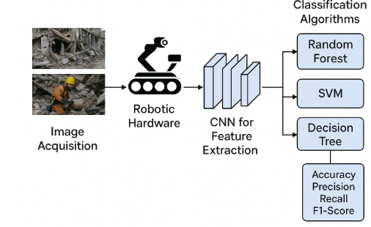

HARDWARE & SOFTWARE REQUIREMENTS:
HARDWARE REQUIRMENTS:
- Processor : intel I3 (min)
- Hard Disk : 500 GB (min).
- Ram : 4 GB (min).
SOFTWARE REQUIRMENTS:
- Operating system : Windows 10 (min)
- Coding Language : python (3.7.0) with Jupyter notebook

